Bull City Inflatables
Is coming to (Org Name or Event)
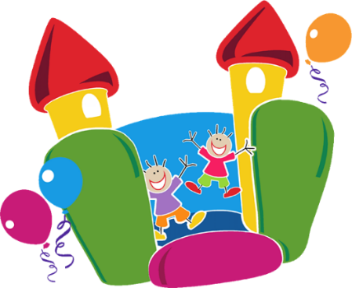
We are having a Bounce House Fundraising Event on __________, please help us raise Funds for ___________.
Bull City Inflatables is coming to join our Fundraiser Event, bringing Bounce Houses that are age appropriate (and Cotton Candy, Pop Corn, or Snow Cones-additional $1/wristband) so our Kids can have fun and raise money!! Bull City Inflatables will be giving proceeds from the Wristband Sales back to us.
Bull City Inflatables is family owned and operated right here in Durham. They are a 5 Star company, that provides Safe and Clean Bounce House and Concession Rentals locally.
Here is what we need to make this a Great Event. If you are interested in letting your child participate in the Fun, Bounce Houses (and Treats), please send $5 for a participation wristband ($6 for Concession) and the bottom section of this flyer filled out by __________.
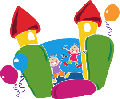Bull City Inflatables 919-627-7132 www.BullCityInflatables.com
-----------------------------------------------------------------------------------------------
Bounce House Fundraiser on ___________ at _______________.
____ Yes, I would like my child____________________ to participate in the Bounce House Play.

